Square-Base Prism
# Source: AI Source: Provided by: [Data Path: Persons Table -> ID Column: 1, Name_En Column: Motasem Essam] -> From: [ChatGPT] on [7/25/2026]
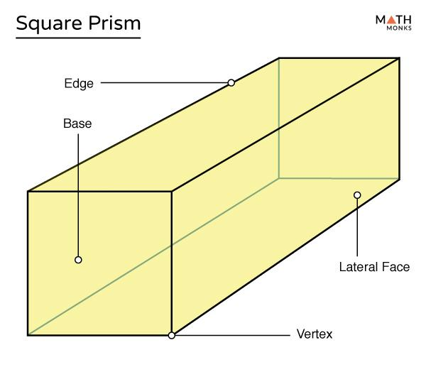
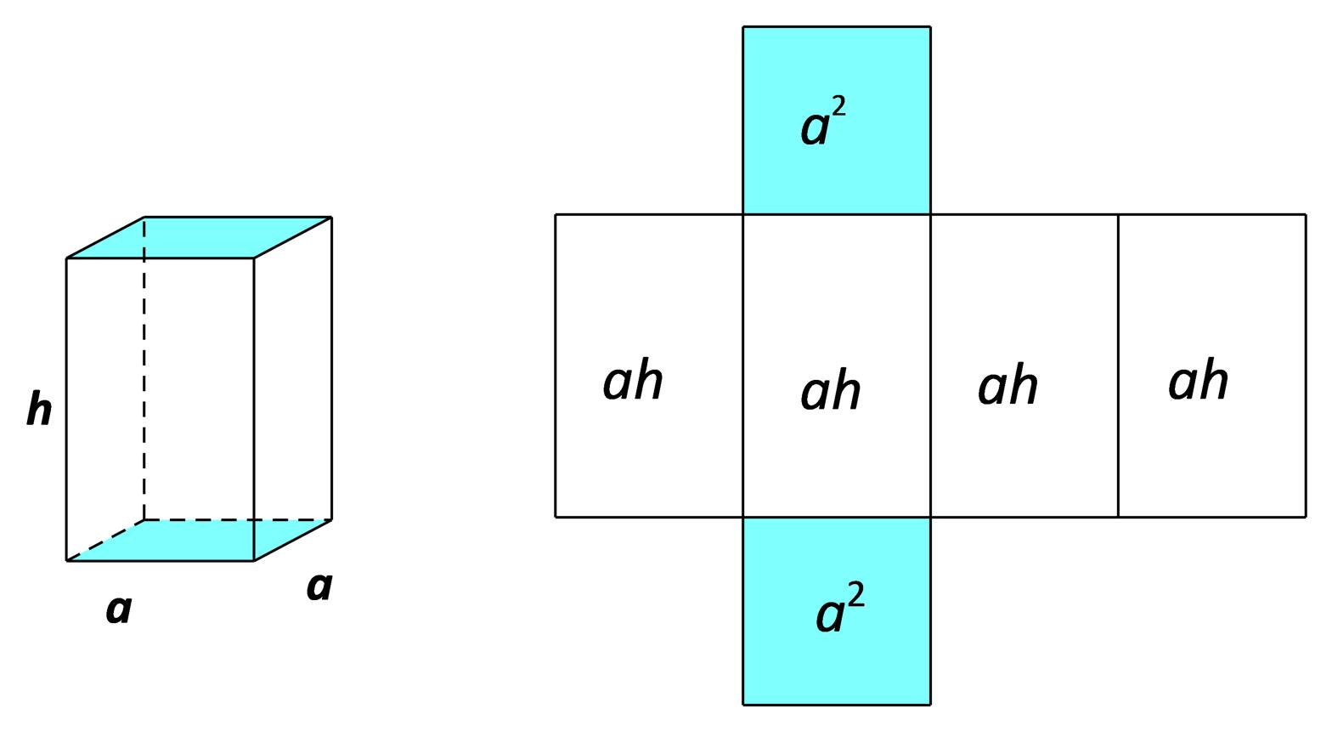
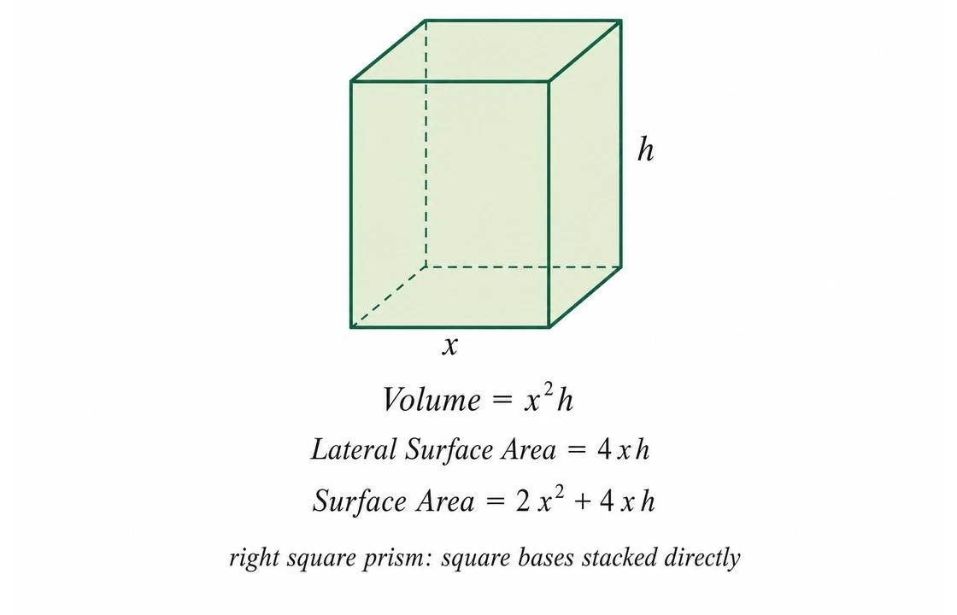

Definition
# Source: AI Source: Provided by: [Data Path: Persons Table -> ID Column: 1, Name_En Column: Motasem Essam] -> From: [ChatGPT] on [7/25/2026]
A square-base prism is a three-dimensional polyhedron whose two bases are congruent, parallel squares connected by four lateral faces.
A square has four equal sides and four right angles. Therefore, a square-base prism has two square bases and four lateral faces.
A square-base prism can be a right square prism, whose lateral edges are perpendicular to the bases, or an oblique square prism, whose lateral edges are inclined to the bases.
A cube is a special type of right square prism in which the lateral edges have the same length as the sides of the square bases. Consequently, all six faces are congruent squares.

Simple Definition
# Source: AI Source: Provided by: [Data Path: Persons Table -> ID Column: 1, Name_En Column: Motasem Essam] -> From: [ChatGPT] on [7/25/2026]
A square-base prism is a solid with two identical, parallel squares joined by four side faces.
Its bases are squares, while its lateral faces are rectangles in a right prism and parallelograms in an oblique prism.

Classification Tree
# Source: AI Source: Provided by: [Data Path: Persons Table -> ID Column: 1, Name_En Column: Motasem Essam] -> From: [ChatGPT] on [7/25/2026]
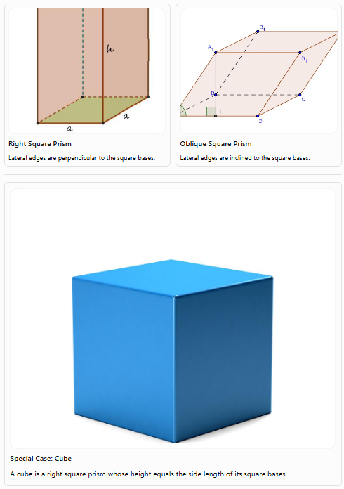
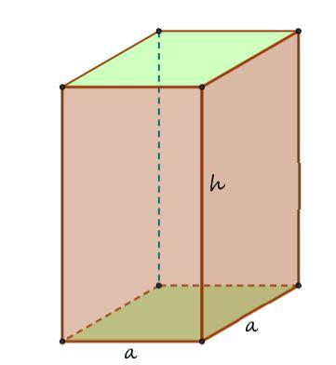
Right Square Prism
Lateral edges are perpendicular to the square bases.
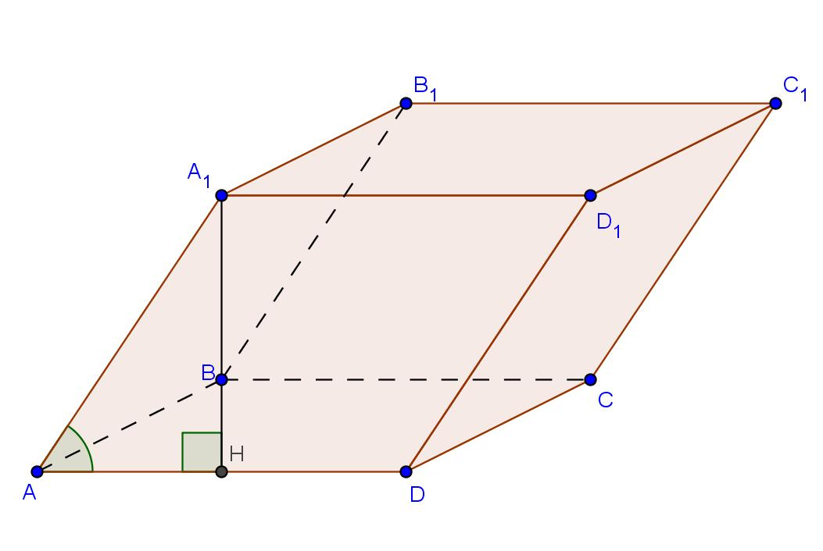
Oblique Square Prism
Lateral edges are inclined to the square bases.
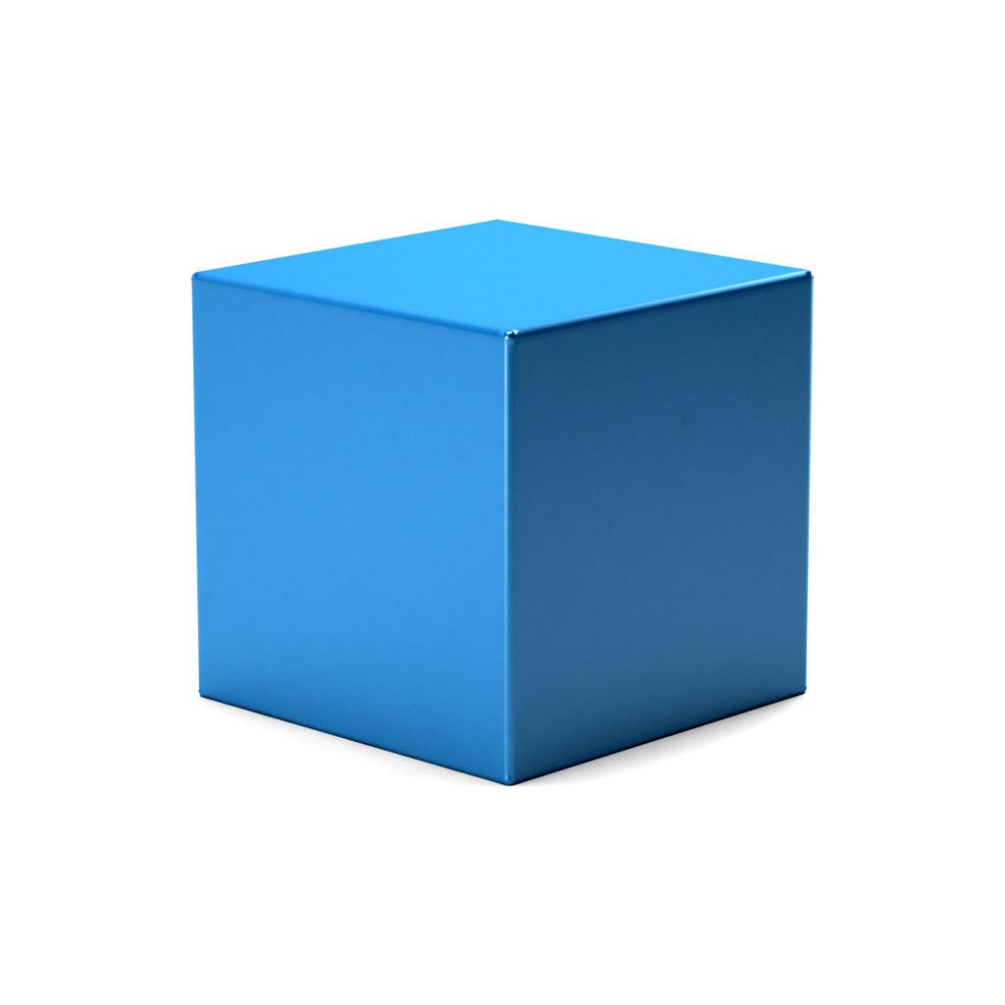
Special Case: Cube
A cube is a right square prism whose height equals the side length of its square bases.

Key Characteristics
# Source: AI Source: Provided by: [Data Path: Persons Table -> ID Column: 1, Name_En Column: Motasem Essam] -> From: [ChatGPT] on [7/25/2026]
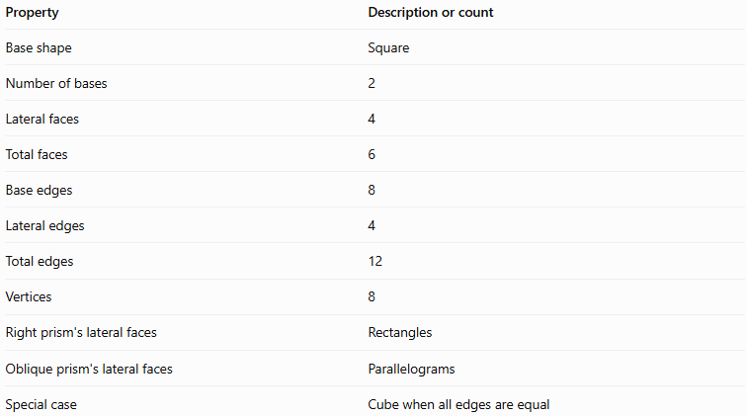
Property | Description or count
Base shape | Square
Number of bases | 2
Lateral faces | 4
Total faces | 6
Base edges | 8
Lateral edges | 4
Total edges | 12
Vertices | 8
Right prism's lateral faces | Rectangles
Oblique prism's lateral faces | Parallelograms
Special case | Cube when all edges are equal

Geometric Representation
# Source: AI Source: Provided by: [Data Path: Persons Table -> ID Column: 1, Name_En Column: Motasem Essam] -> From: [ChatGPT] on [7/25/2026]
The main components of a square-base prism are:
- Square bases: Two congruent, parallel squares.
- Lateral faces: Four faces connecting the corresponding edges of the bases.
- Base edges: Eight edges in total, with four around each square.
- Lateral edges: Four edges joining corresponding vertices of the two bases.
- Vertices: Eight corner points.
- Height: The perpendicular distance between the two base planes.
- Base side length: The length of each of the four equal sides of a square base.
For a right square prism, let $a$ represent the base side length and $h$ represent the perpendicular height.

Mathematical Representations and Formulas
# Source: AI Source: Provided by: [Data Path: Persons Table -> ID Column: 1, Name_En Column: Motasem Essam] -> From: [ChatGPT] on [7/25/2026]
Let:
- $a$ = side length of a square base
- $h$ = perpendicular height of the prism
- $B$ = area of one base
- $A_{L}$ = lateral surface area
- $A_{T}$ = total surface area
- $V$ = volume
- $d$ = space diagonal of a right square prism

A. Number of faces, edges, and vertices
# Source: AI Source: Provided by: [Data Path: Persons Table -> ID Column: 1, Name_En Column: Motasem Essam] -> From: [ChatGPT] on [7/25/2026]
A square-base prism is a quadrilateral prism, so $n=4$.
For an $n$-gonal prism:
$$F=n+2, E=3n, V=2n$$
Substituting $n=4$:
$$F=4+2=\boxed{6}$$
$$E=3\left(4\right)=\boxed{12}$$
$$V=2\left(4\right)=\boxed{8}$$

B. Area of the square base
# Source: AI Source: Provided by: [Data Path: Persons Table -> ID Column: 1, Name_En Column: Motasem Essam] -> From: [ChatGPT] on [7/25/2026]
The area of a square is the side length squared:
$$\boxed{B=a^{2}}$$
The perimeter of the base is:
$$\boxed{p=4a}$$

C. Volume
# Source: AI Source: Provided by: [Data Path: Persons Table -> ID Column: 1, Name_En Column: Motasem Essam] -> From: [ChatGPT] on [7/25/2026]
The volume of a prism is its base area multiplied by its perpendicular height:
$$V=Bh$$
Since $B=a^{2}$:
$$\boxed{V=a^{2}h}$$
This formula applies to both right and oblique square-base prisms.

D. Lateral surface area
# Source: AI Source: Provided by: [Data Path: Persons Table -> ID Column: 1, Name_En Column: Motasem Essam] -> From: [ChatGPT] on [7/25/2026]
For a right square prism, the lateral surface area is the base perimeter multiplied by the height:
$$A_{L}=ph$$
Since $p=4a$:
$$\boxed{A_{L}=4ah}$$
For an oblique square-base prism, the actual areas of its four lateral parallelograms must be added together.

E. Total surface area
# Source: AI Source: Provided by: [Data Path: Persons Table -> ID Column: 1, Name_En Column: Motasem Essam] -> From: [ChatGPT] on [7/25/2026]
The total surface area includes the four lateral faces and the two square bases:
$$A_{T}=A_{L}+2B$$
Substituting the formulas:
$$A_{T}=4ah+2a^{2}$$
Therefore, for a right square prism:
$$\boxed{A_{T}=4ah+2a^{2}}$$

F. Space diagonal
# Source: AI Source: Provided by: [Data Path: Persons Table -> ID Column: 1, Name_En Column: Motasem Essam] -> From: [ChatGPT] on [7/25/2026]
For a right square prism, the space diagonal connects opposite vertices through the interior.
Using the three-dimensional Pythagorean theorem:
$$d=\sqrt{a^{2}+a^{2}+h^{2}}$$
Thus:
$$\boxed{d=\sqrt{2a^{2}+h^{2}}}$$

G. Special case: Cube
# Source: AI Source: Provided by: [Data Path: Persons Table -> ID Column: 1, Name_En Column: Motasem Essam] -> From: [ChatGPT] on [7/25/2026]
When the height equals the base side length, $h=a$, the right square prism becomes a cube.
Its volume is:
$$\boxed{V=a^{3}}$$
Its total surface area is:
$$\boxed{A_{T}=6a^{2}}$$
Its space diagonal is:
$$\boxed{d=a\sqrt{3}}$$

Worked Examples
# Source: AI Source: Provided by: [Data Path: Persons Table -> ID Column: 1, Name_En Column: Motasem Essam] -> From: [ChatGPT] on [7/25/2026]
Example 1: Counting faces, edges, and vertices
Problem: Determine the number of faces, edges, and vertices of a square-base prism.
Solution:
The base is a square, which has four sides. Therefore, $n=4$.
$$F=n+2=4+2=\boxed{6}$$
$$E=3n=3\left(4\right)=\boxed{12}$$
$$V=2n=2\left(4\right)=\boxed{8}$$
Answer: The square-base prism has 6 faces, 12 edges, and 8 vertices.
Example 2: Calculating volume
Problem: A right square prism has a base side length of $6\text{ cm}$ and a height of $10\text{ cm}$. Find its volume.
Step 1: Calculate the base area.
$$B=a^{2}=6^{2}=36{\text{ cm}}^{2}$$
Step 2: Calculate the volume.
$$V=Bh=36\left(10\right)$$
$$\boxed{V=360{\text{ cm}}^{3}}$$
Answer: $360{\text{ cm}}^{3}$.
Example 3: Calculating lateral surface area
Problem: A right square prism has a base side length of $5\text{ cm}$ and a height of $12\text{ cm}$. Find its lateral surface area.
Use:
$$A_{L}=4ah$$
Substitute the values:
$$A_{L}=4\left(5\right)\left(12\right)$$
$$\boxed{A_{L}=240{\text{ cm}}^{2}}$$
Answer: $240{\text{ cm}}^{2}$.
Example 4: Calculating total surface area
Problem: A right square prism has a base side length of $4\text{ cm}$ and a height of $9\text{ cm}$. Find its total surface area.
Use:
$$A_{T}=4ah+2a^{2}$$
Substitute:
$$A_{T}=4\left(4\right)\left(9\right)+2\left(4^{2}\right)$$
$$A_{T}=144+32$$
$$\boxed{A_{T}=176{\text{ cm}}^{2}}$$
Answer: $176{\text{ cm}}^{2}$.
Example 5: Calculating the space diagonal
Problem: A right square prism has a base side length of $3\text{ cm}$ and a height of $4\text{ cm}$. Find its space diagonal.
Use:
$$d=\sqrt{2a^{2}+h^{2}}$$
Substitute:
$$d=\sqrt{2\left(3^{2}\right)+4^{2}}$$
$$d=\sqrt{18+16}$$
$$d=\sqrt{34}$$
$$\boxed{d≈5.83\text{ cm}}$$
Answer: Approximately $5.83\text{ cm}$.
Example 6: Verifying Euler's formula
Euler's formula for a convex polyhedron is:
$$V-E+F=2$$
For a square-base prism:
$$8-12+6=2$$
$$\boxed{2=2}$$
Therefore, the square-base prism satisfies Euler's formula.

Comparison with Related Quadrilateral Prisms
# Source: AI Source: Provided by: [Data Path: Persons Table -> ID Column: 1, Name_En Column: Motasem Essam] -> From: [ChatGPT] on [7/25/2026]
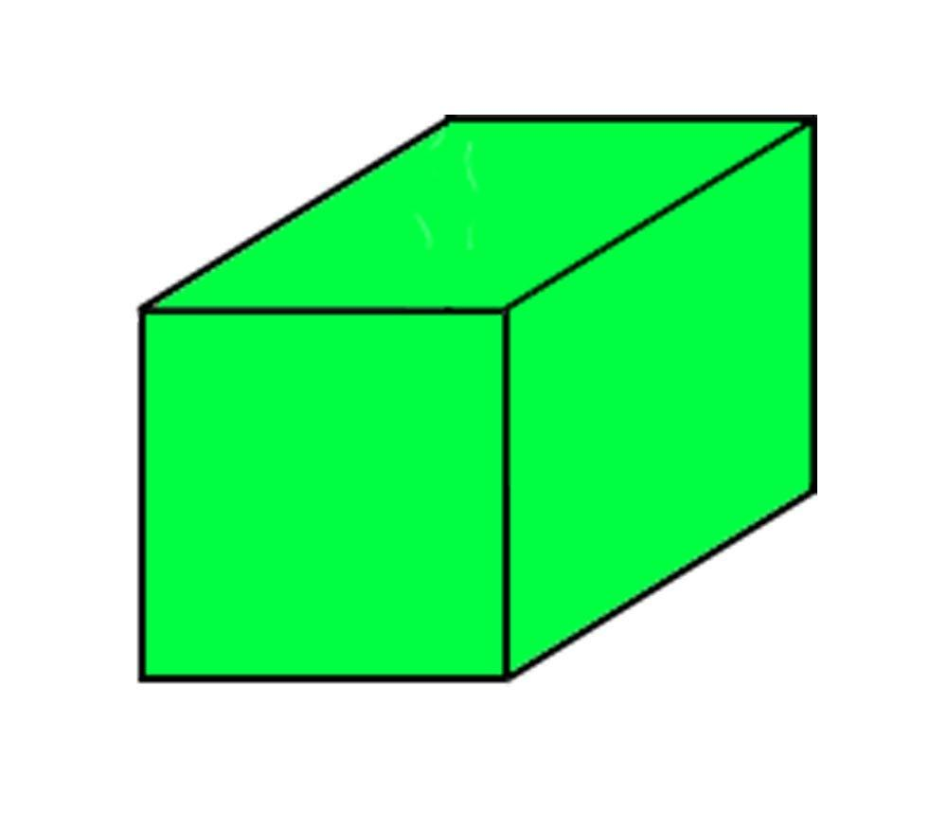
Rectangular-Base Prism
Has rectangular bases. A right version is a cuboid, with all six faces rectangular.
Square-Base Prism
Has square bases. A right version has two square bases and four rectangular lateral faces.
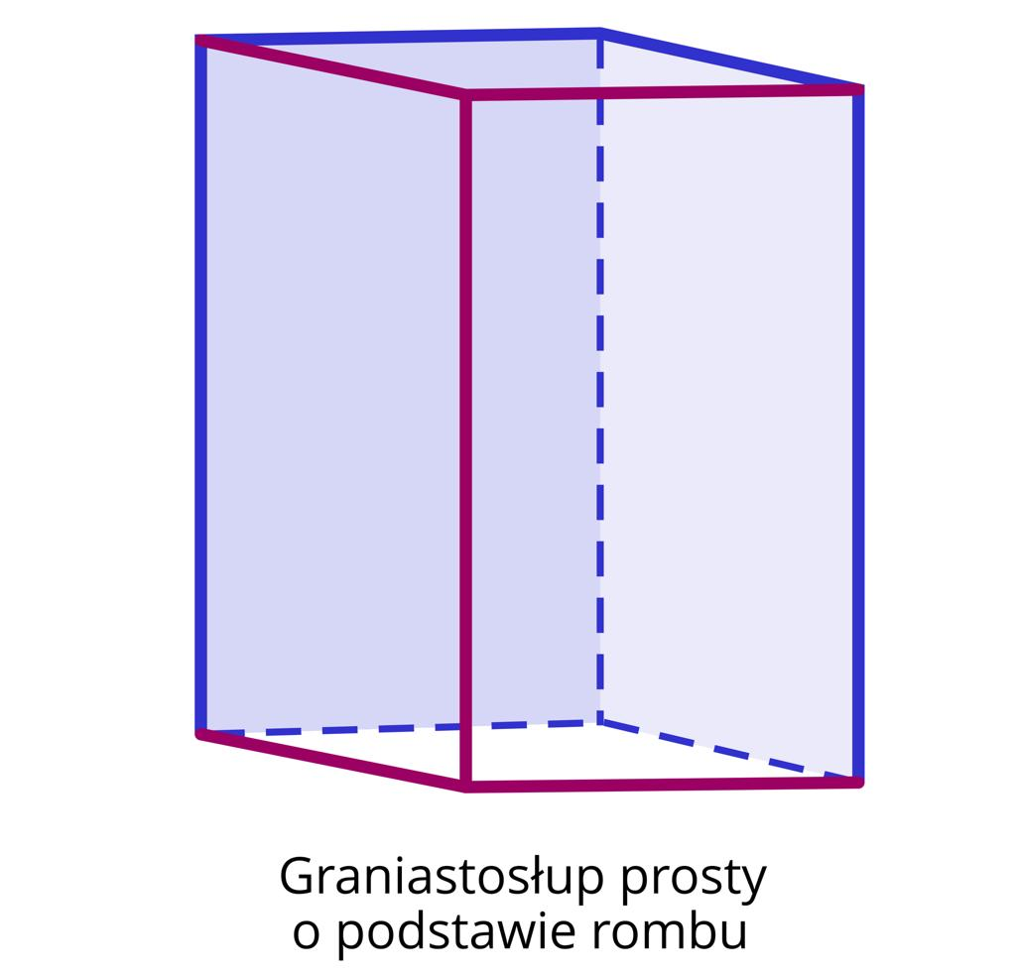
Rhombus-Base Prism
Has rhombus bases, whose four sides are equal but whose angles need not be right angles.
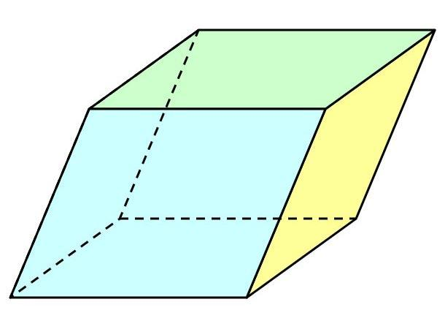
Parallelogram-Base Prism
Has parallelogram bases with opposite sides parallel and equal.
Important distinction: Every square is a rectangle, so a square-base prism also has rectangular bases in the broader mathematical sense. However, it is classified specifically as a square-base prism because its bases have four equal sides.
A cube is a special square-base prism in which all six faces are squares.

Constructing Square-Base Prism in Solid Geometry

Instruments Used
# Source: AI Source: Provided by: [Data Path: Persons Table -> ID Column: 1, Name_En Column: Motasem Essam] -> From: [ChatGPT] on [7/25/2026]
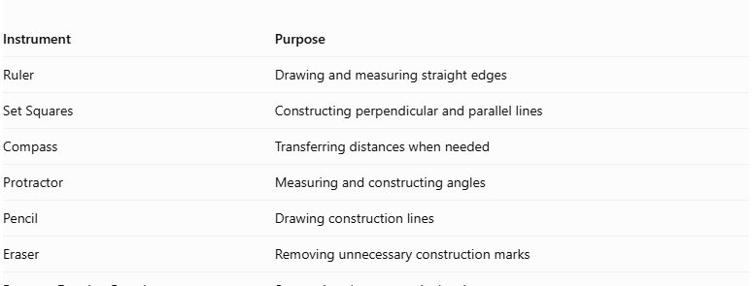
Instrument | Purpose
Ruler | Drawing and measuring straight edges
Set Squares | Constructing perpendicular and parallel lines
Compass | Transferring distances when needed
Protractor | Measuring and constructing angles
Pencil | Drawing construction lines
Eraser | Removing unnecessary construction marks
Paper or Drawing Board | Supporting the geometric drawing

Construction Procedures

Isometric Construction
# Source: AI Source: Provided by: [Data Path: Persons Table -> ID Column: 1, Name_En Column: Motasem Essam] -> From: [ChatGPT] on [7/25/2026]
- Determine the side length of the square base and the required height.
- Draw the first base edge in the selected isometric direction.
- Draw the two remaining visible base directions at the appropriate isometric angles.
- Complete the square-base representation.
- From the corresponding base vertices, draw vertical edges representing the prism height.
- Draw the upper square base by connecting the endpoints of the vertical edges.
- Ensure that the upper and lower bases are congruent and parallel.
- Complete the visible and hidden edges.
- Refine the drawing and label the dimensions.
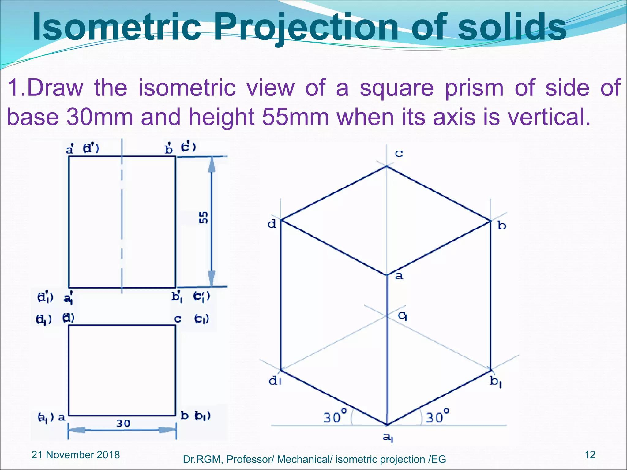

Orthographic Construction
# Source: AI Source: Provided by: [Data Path: Persons Table -> ID Column: 1, Name_En Column: Motasem Essam] -> From: [ChatGPT] on [7/25/2026]
- Determine the base side length and prism height.
- Draw the front view as a rectangle with the base side length and height.
- Draw the top view as a square.
- Draw the side view as a rectangle with the same dimensions as the front view.
- Align the three views according to the selected orthographic projection convention.
- Ensure that corresponding dimensions are consistent.
- Add visible and hidden lines where necessary.
- Label the base side length and prism height.

Face-Based Construction
# Source: AI Source: Provided by: [Data Path: Persons Table -> ID Column: 1, Name_En Column: Motasem Essam] -> From: [ChatGPT] on [7/25/2026]
- Draw the first square base.
- Determine the required prism height.
- Draw a second congruent square base at the required distance.
- Keep the two bases parallel.
- Connect the corresponding vertices of both squares.
- Complete the four lateral faces.
- Check that all lateral faces are rectangles for a right square prism.
- Refine the edges and identify the visible surfaces.

Edge-Based Construction
# Source: AI Source: Provided by: [Data Path: Persons Table -> ID Column: 1, Name_En Column: Motasem Essam] -> From: [ChatGPT] on [7/25/2026]
- Select a starting vertex.
- Draw two perpendicular edges representing the sides of the square base.
- Complete the square base using equal side lengths.
- Draw the lateral edges from the four base vertices.
- Ensure that the lateral edges are equal and perpendicular to the base for a right prism.
- Connect the upper endpoints to form the second square base.
- Check that the corresponding base edges are equal and parallel.
- Complete the solid representation.

Net-Based Construction
# Source: AI Source: Provided by: [Data Path: Persons Table -> ID Column: 1, Name_En Column: Motasem Essam] -> From: [ChatGPT] on [7/25/2026]
- Draw four equal rectangles representing the lateral faces.
- Arrange the four rectangles in a connected strip.
- Attach two congruent squares to suitable edges of the strip to represent the bases.
- Ensure that each rectangle has one dimension equal to the square's side length.
- Ensure that the other rectangular dimension represents the prism height.
- Add tabs if needed for physical assembly.
- Cut out the net.
- Fold along the edges and join the matching boundaries to form the square-base prism.
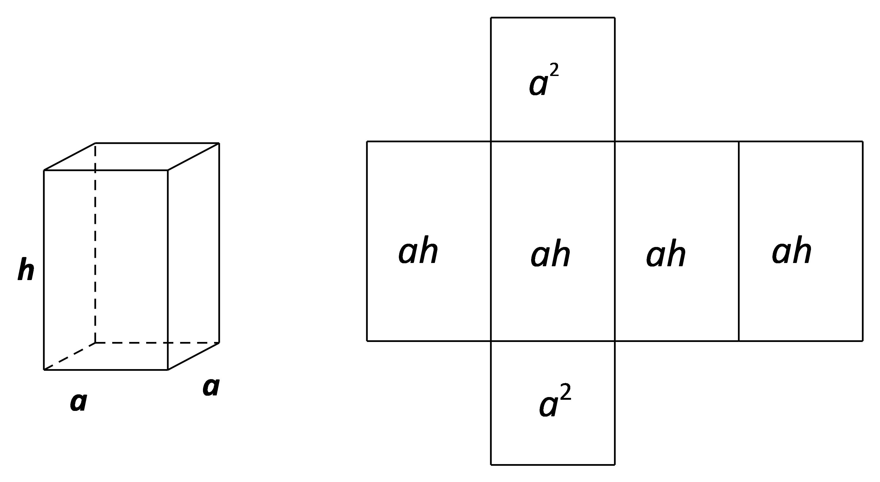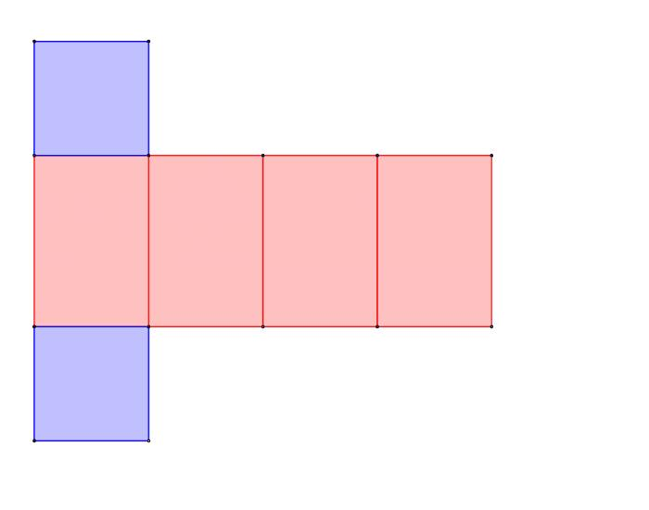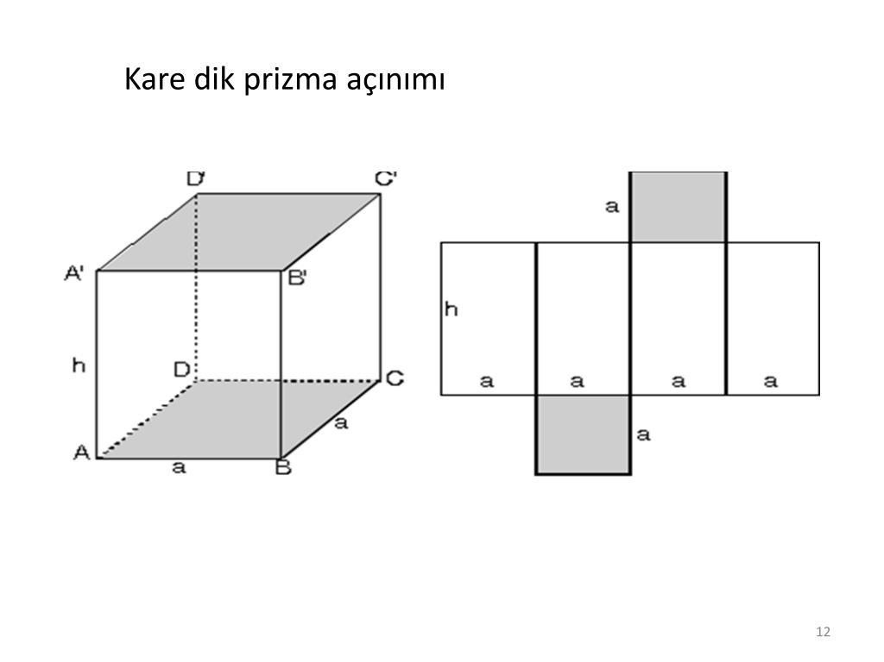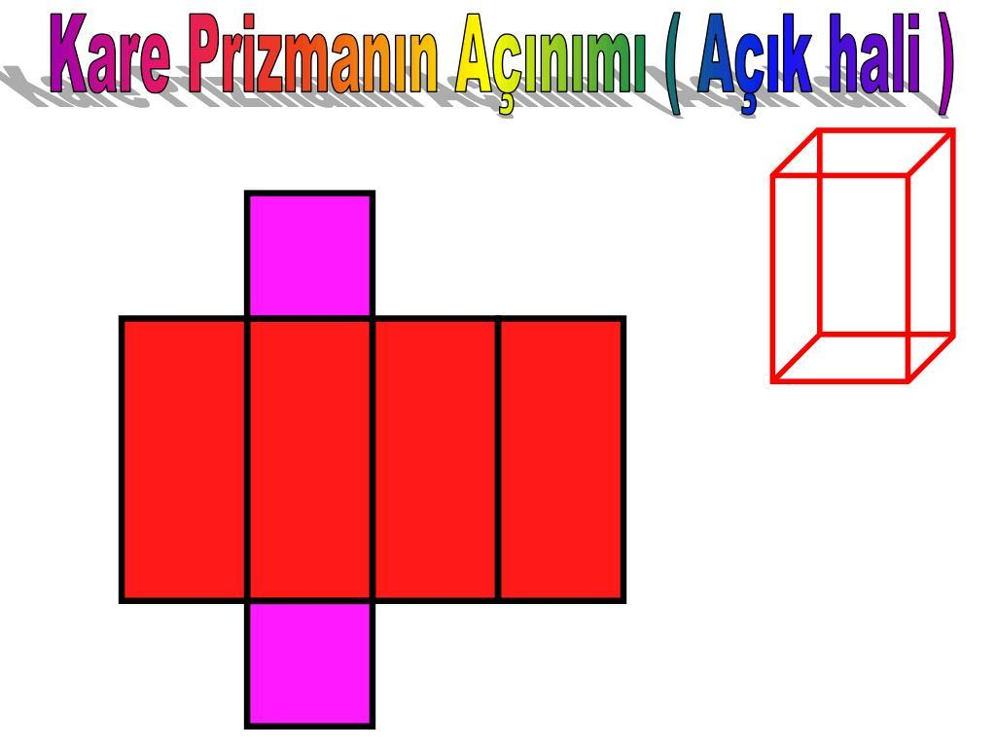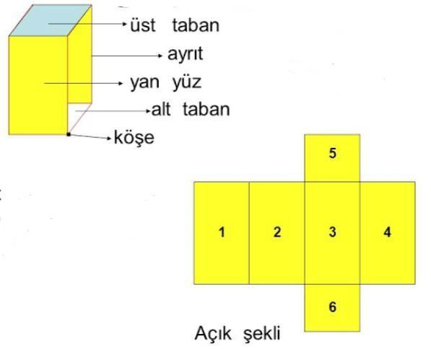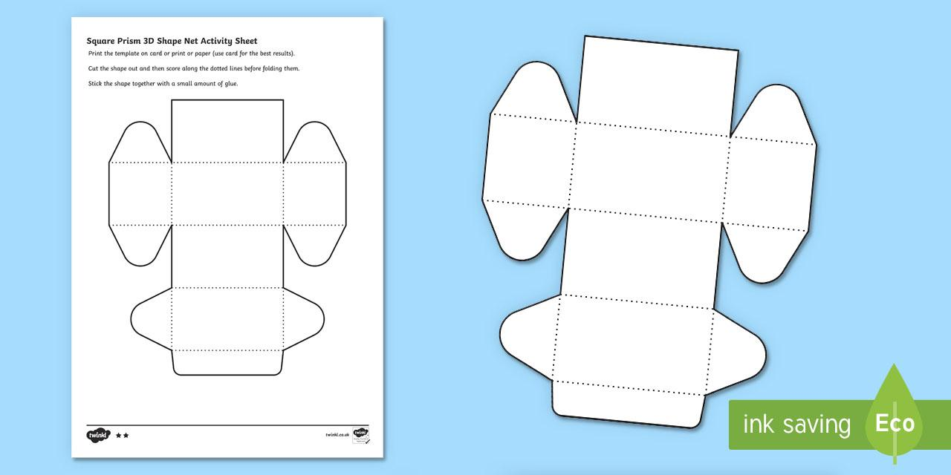

Applications of Square-Base Prisms
# Source: AI Source: Provided by: [Data Path: Persons Table -> ID Column: 1, Name_En Column: Motasem Essam] -> From: [ChatGPT] on [7/25/2026]
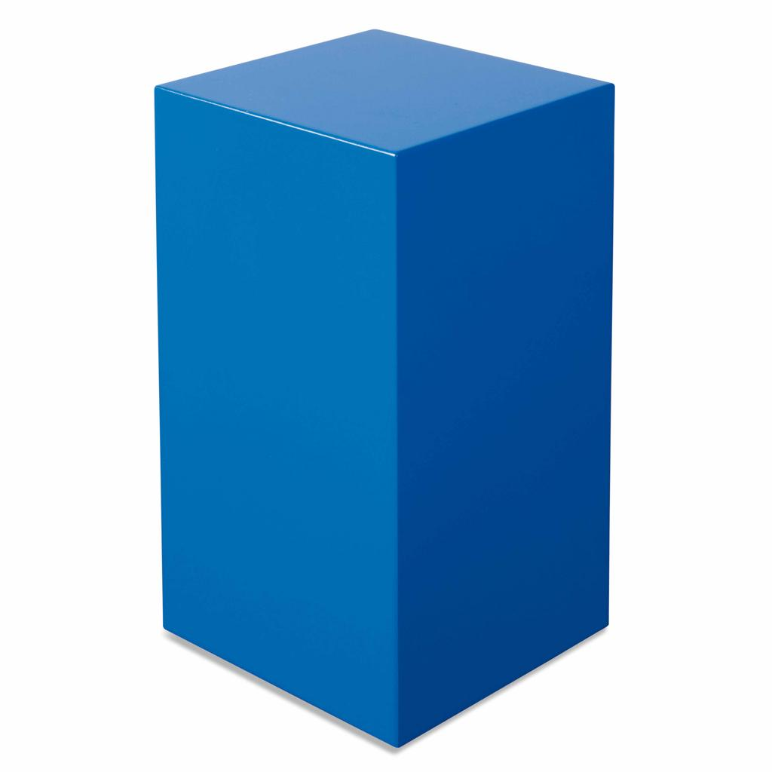
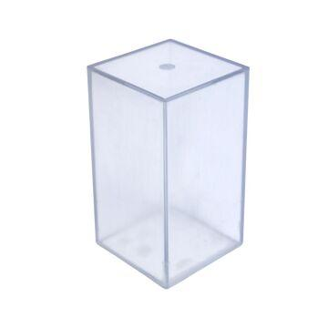
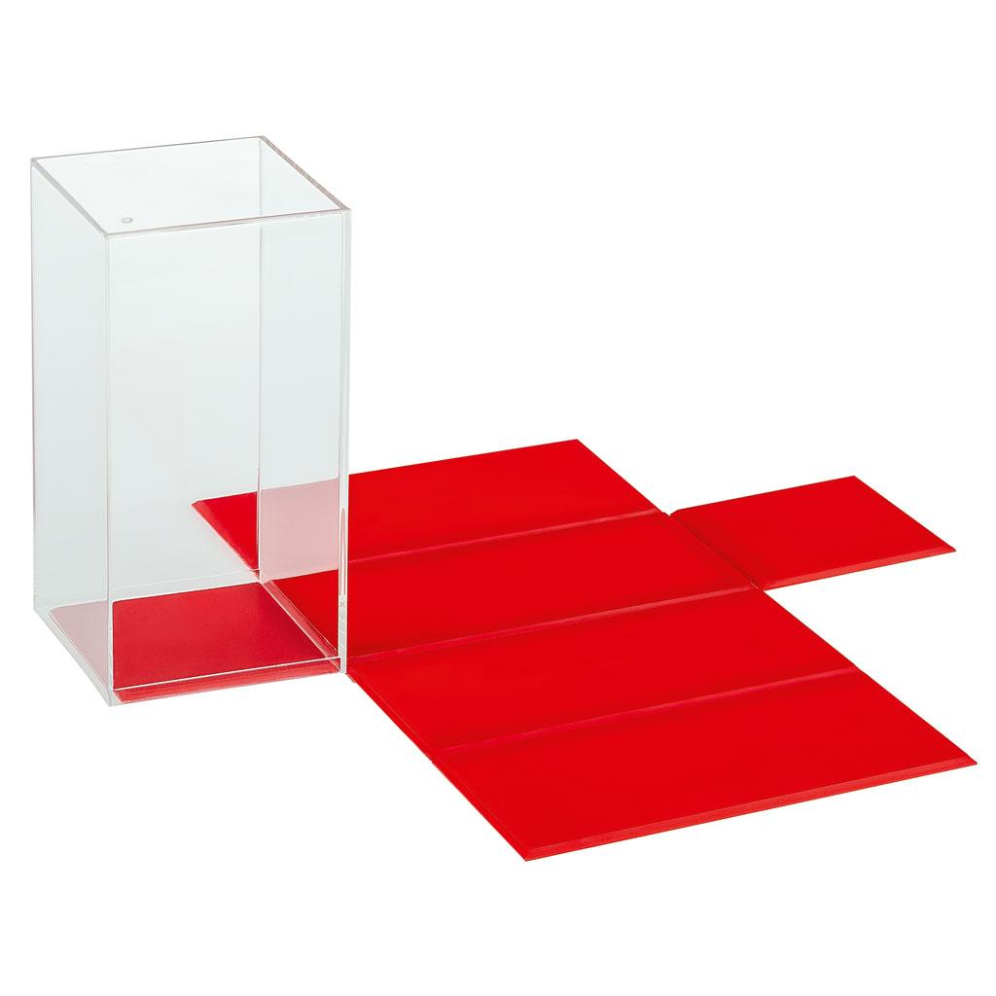
Square-base prisms are useful in:
- Construction: Square columns, posts, and structural blocks.
- Packaging: Boxes and containers with square cross-sections.
- Manufacturing: Components with square profiles.
- Education: Demonstrating volume, surface area, and three-dimensional geometry.
- Computer graphics: Modeling solid objects with square bases.

Key Points
# Source: AI Source: Provided by: [Data Path: Persons Table -> ID Column: 1, Name_En Column: Motasem Essam] -> From: [ChatGPT] on [7/25/2026]
- A square-base prism has two congruent, parallel square bases.
- It has four lateral faces, six faces in total, twelve edges, and eight vertices.
- Its base area is $B=a^{2}$.
- Its volume is $V=a^{2}h$.
- For a right square prism, its lateral surface area is $A_{L}=4ah$.
- Its total surface area is $A_{T}=4ah+2a^{2}$.
- Its space diagonal is $d=\sqrt{2a^{2}+h^{2}}$ when it is a right prism.
- A cube is a special square-base prism with $h=a$.

Conclusion
# Source: AI Source: Provided by: [Data Path: Persons Table -> ID Column: 1, Name_En Column: Motasem Essam] -> From: [ChatGPT] on [7/25/2026]
A square-base prism is a quadrilateral prism whose two congruent, parallel bases are squares. It has six faces, twelve edges, and eight vertices, just like other quadrilateral prisms, but its base shape gives it a distinct classification.
Its volume is calculated using the square base area and perpendicular height, while its surface area depends on the dimensions of its bases and lateral faces. When the prism is right, these measurements can be determined using straightforward formulas involving the base side length and height.
A cube is the special case in which the height equals the side length of the square bases, making all six faces congruent squares. Understanding this relationship helps distinguish square-base prisms from general rectangular-base prisms and other quadrilateral prisms.

